# CS 255 System Design Document

This template lays out all the different sections that you need to complete for Project Two. Each section has guidance to prompt your thinking. You will need to continually reference the interview transcript as you work to make sure that you are addressing your client’s needs. There is no required length for the final document. Instead the goal is to complete each section based on what your client’s needs are. Remove this note when you are finished, and replace all bracketed text with the relevant information.

## UML Diagrams

### UML Use Case Diagram

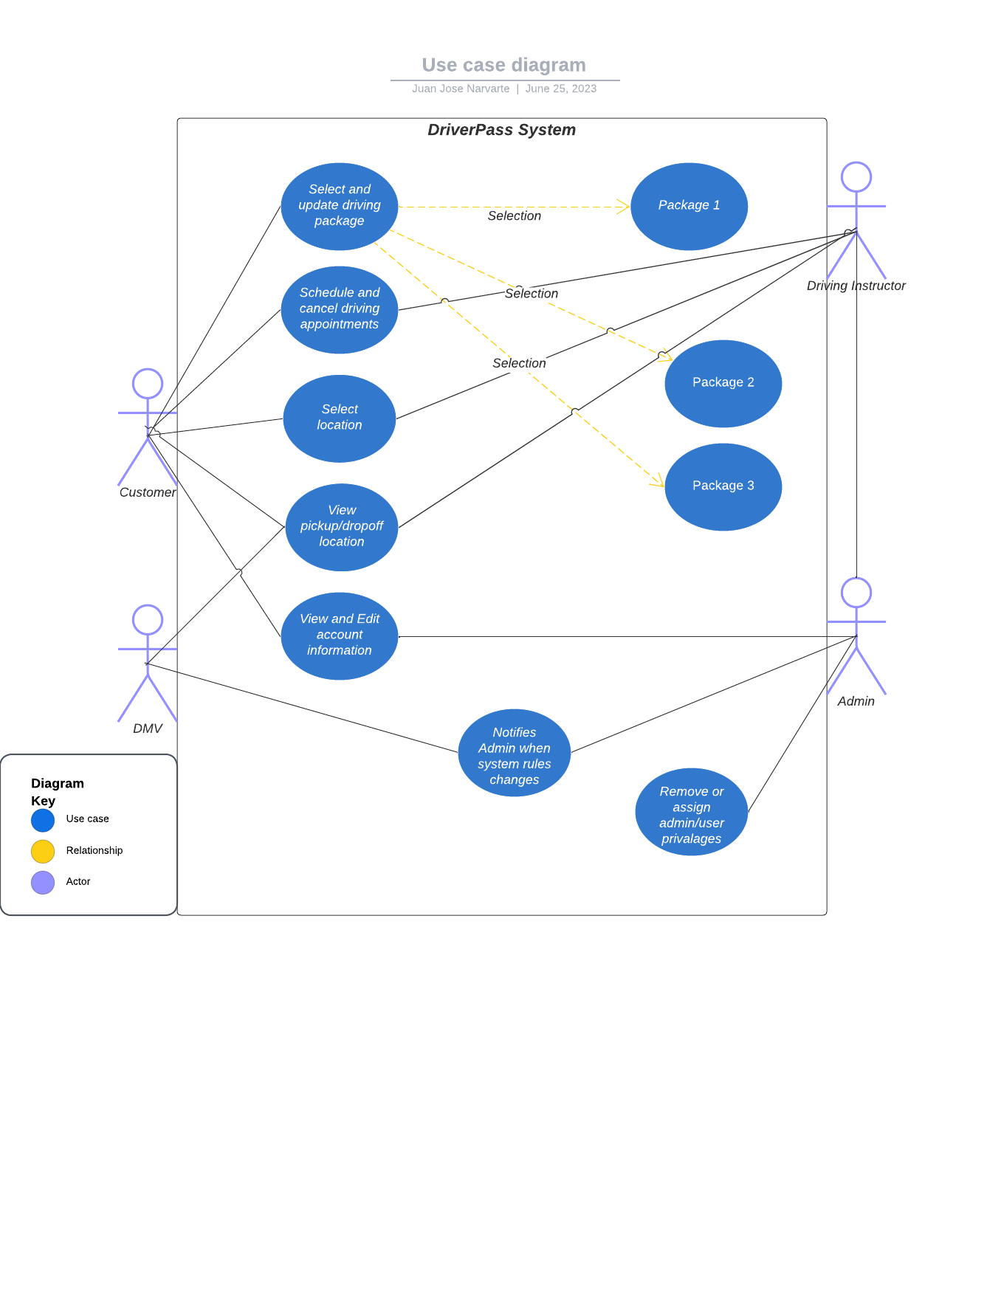

### UML Activity Diagrams

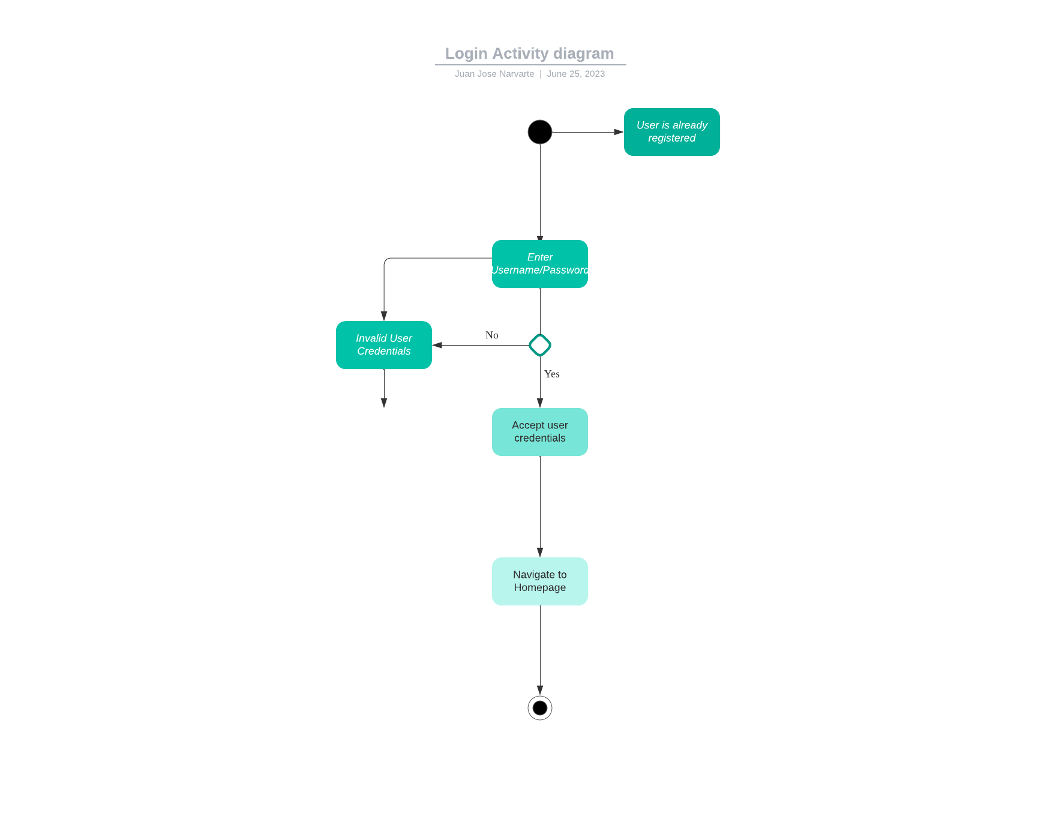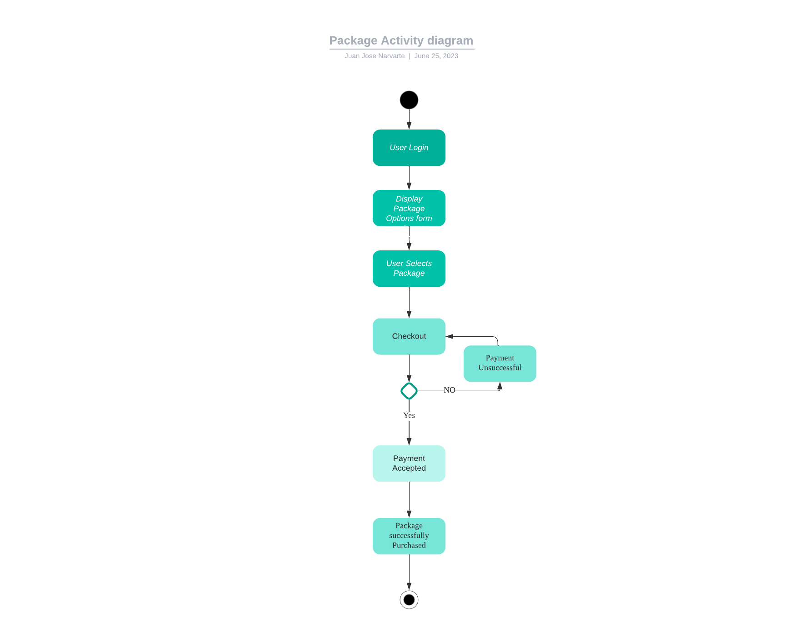

### UML Sequence Diagram

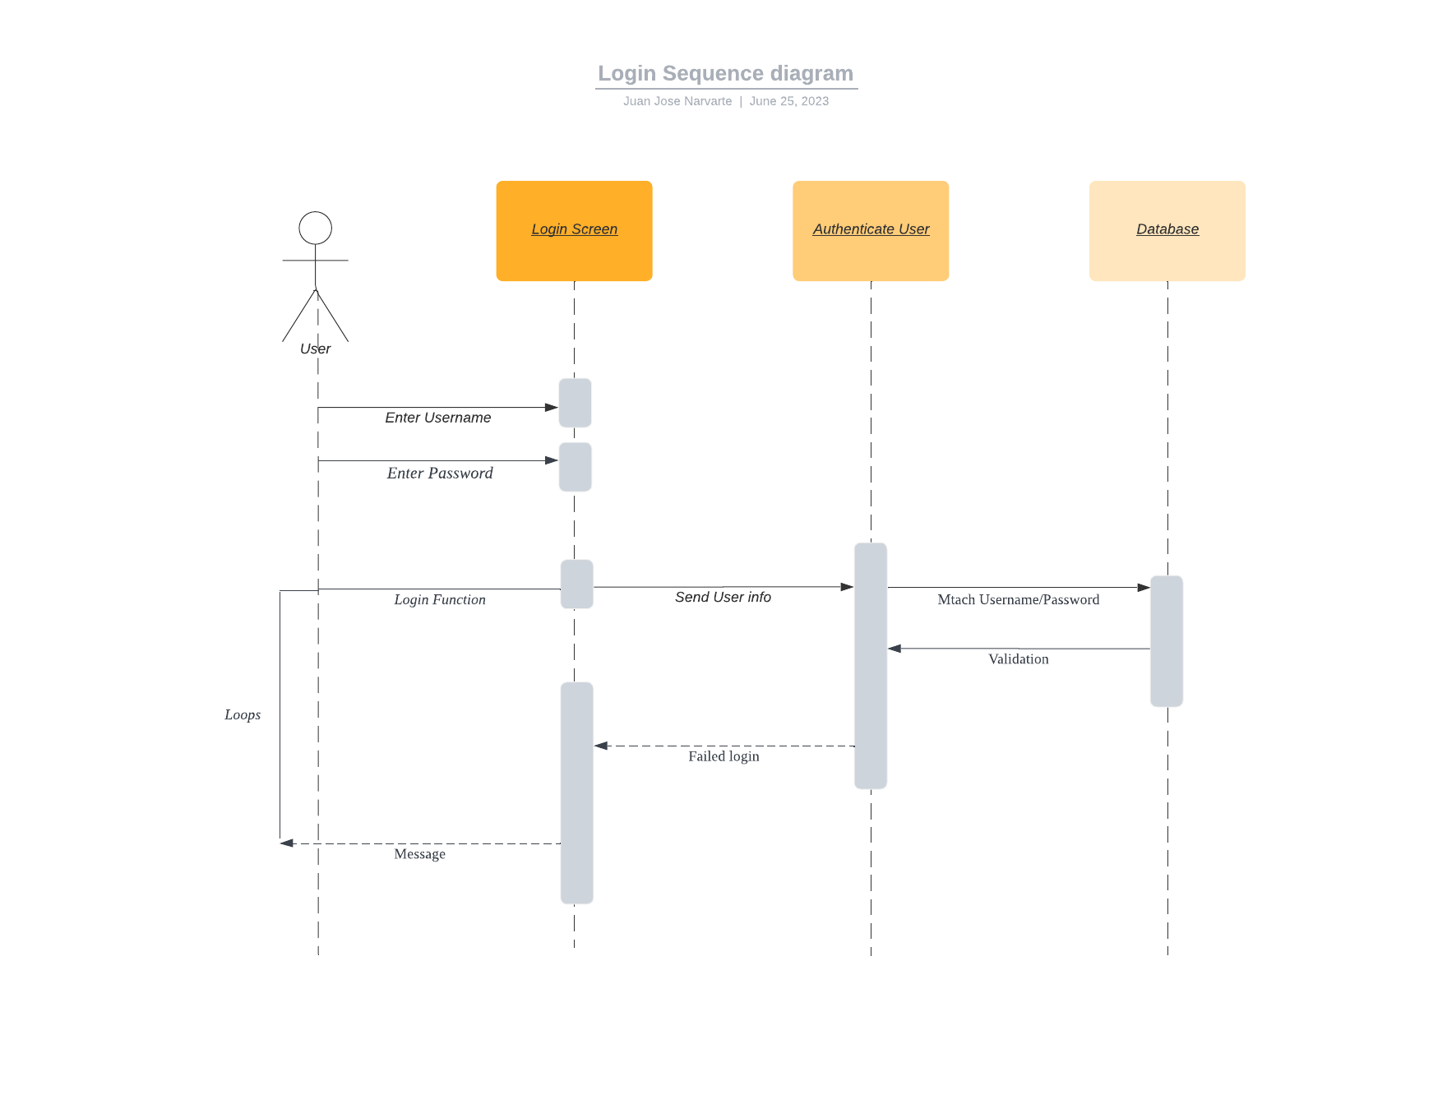

### UML Class Diagram

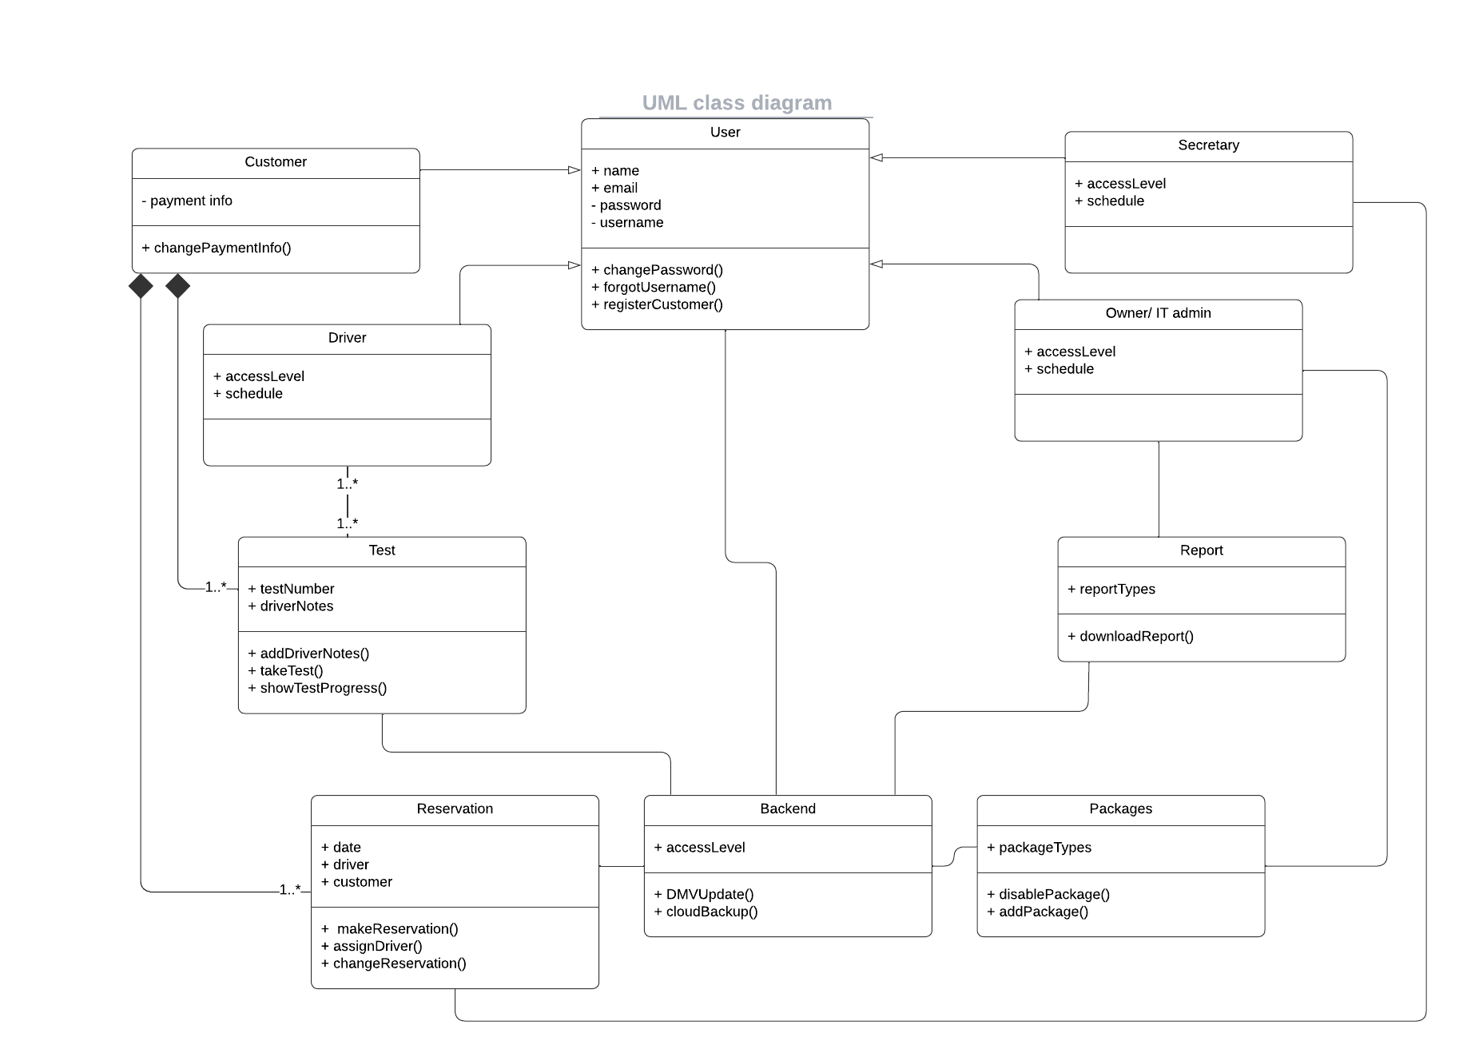

## Technical Requirements

*The Python programming language will be used to create a web application that will be used to host the DriverPass system. The hosting service will keep the server code, the core Python code, and the database for user login data.*